Motel & Church Directions

Hampton Inn
2700 South Loop 256, Palestine, TX 75801
(903) 723-0016 FAX (903) 723-0004

19 N To Athens
287 NW To Corsicana To Tyler
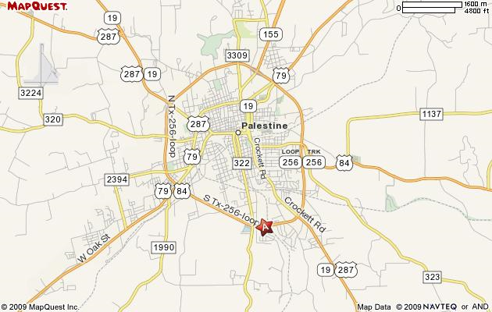
To Fairfield To Beaumont

From Dallas take Interstate 45 South (toward Houston) and go to Corsicana.
Take the 287 exit South and head toward Palestine. (About an hour drive from the Interstate 45 turnoff). When you get to Palestine look for the 256 Loop. Take the TX 256 loop ramp, it’s about 4 miles to the Hampton Inn. If you are running late, your room will be held for you.

To get to the church from the motel, continue on the 256 loop to route 19/287 and go north into downtown. Make a left on E. Crawford Street, the church is on the right. Or once downtown, you can follow 287 to the west and make a right on S. Sycamore to E. Crawford. (See bigger map on back)

First Christian Church
113 E. Crawford
(903)729-5440 or (903)729-3277
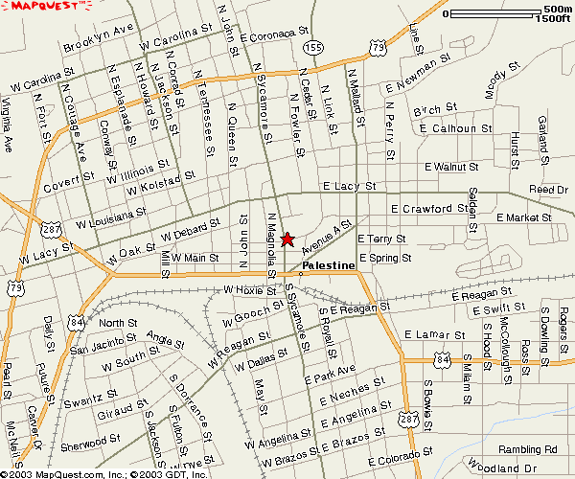

First Christian Church
113 E. Crawford
(903)729-5440 or (903)729-3277

